Eagle schematic guide V.1
- Download and install

- Download and install from here https://cadsoft.io

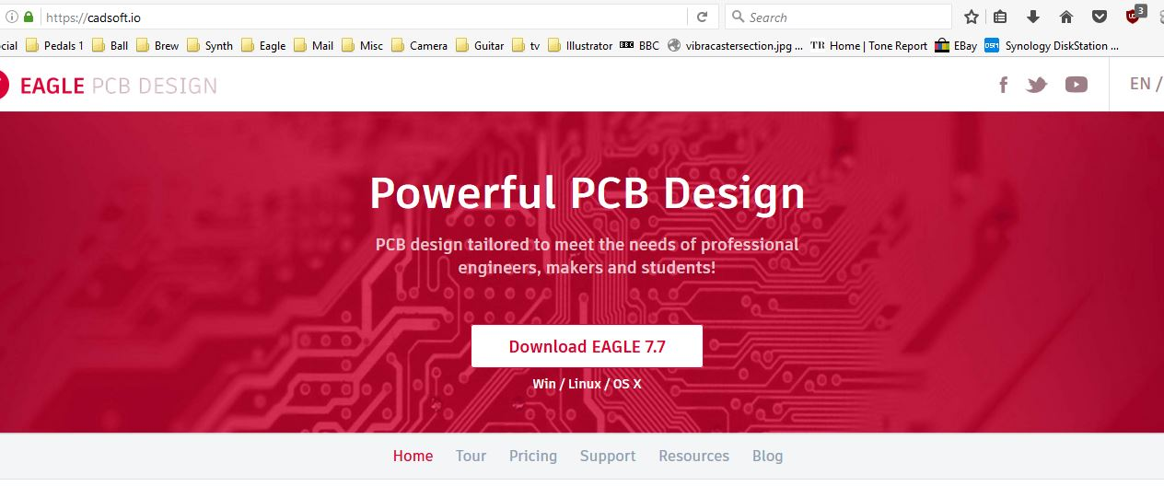

- Create a new project and schematic
- From the main screen create a new project

> File > New > Project

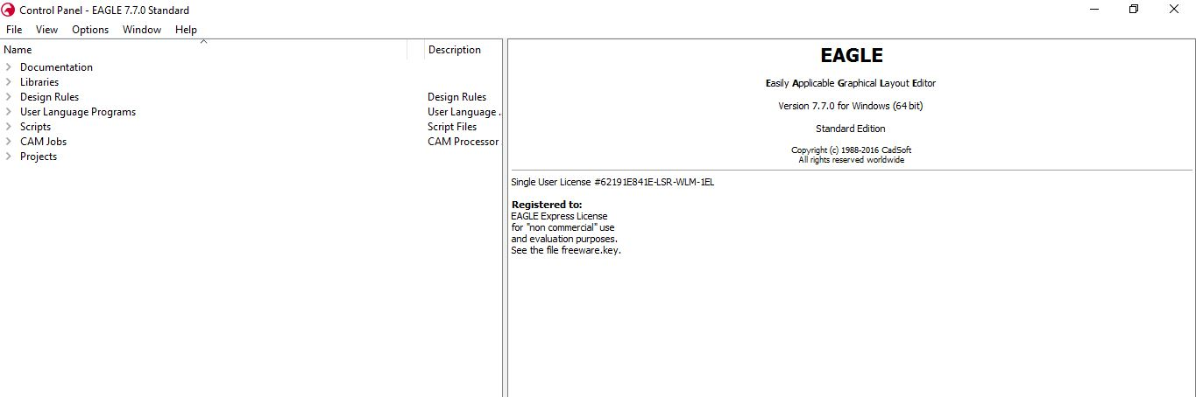

- Name the project.
- Within the project create a new schematic (The active project is highlighted with the large green spot)

> File > New > schematic

- Libraries
This is mega important!!!! Get this right and you’ll be off to a fligher, get it wrong and you’ll tie yourself in knots

Before you get going there’s a need to establish your component library. If you try to use the ones supplied with eagle you will get totally lost.

The component library defines the attributes of the parts you have placed onto your schematic and what they look like when they are placed onto your PCB board layout.

You may think that the 1000’s of resistors in the eagle libraries are all the same, they often look the same in the schematic but when you’ve spent hours drawing your circuit and finally generate your board you’ll find that the component differences can be significant. Choosing the right library and the right parts from the off will save you a bunch of headache.

I’d suggest using the madbean library which you can get here (you might need to register)

http://www.madbeanpedals.com/forum/index.php?topic=12945.0

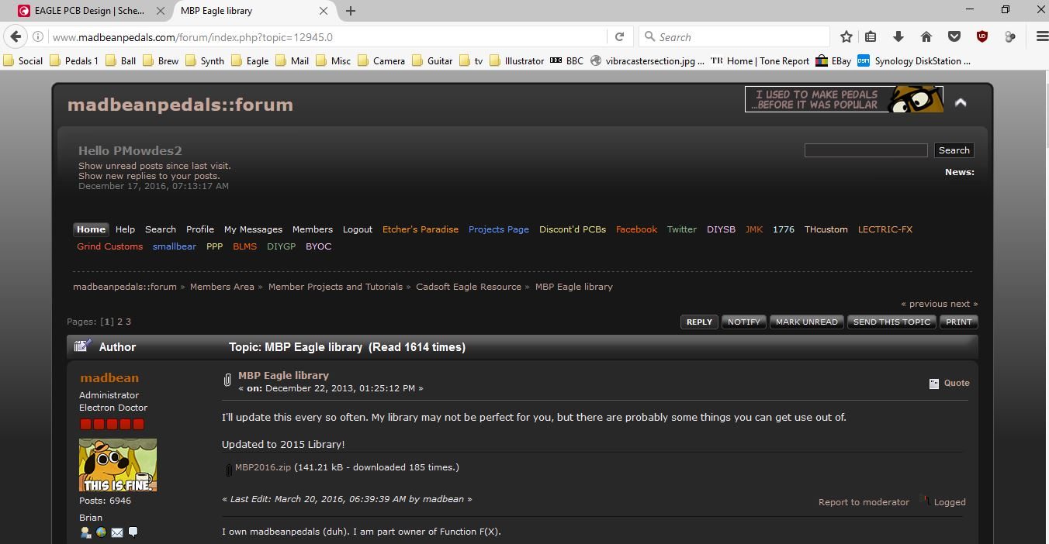

The other library is the Gaussmanov library, which is pretty comprehensive but the solder pads on the board layout are very small (something i discovered after my first batch was delivered). If you want to have a look you can get it from here

http://gaussmarkov.net/wordpress/tools/software/eagle/eagle-2-libraries/



- Start by clearing the existing libraries from the lbr folder within the libraries folder in the main Eagle software folder (Cut them from the folder and paste them elsewhere for safe keeping)
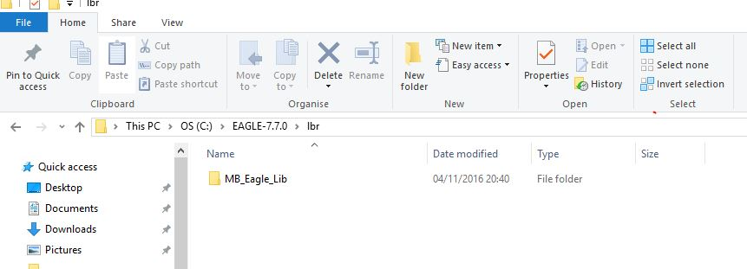

- Download the Madbean library file, unzip it and place the file folder within the lbr folder in the main Eagle software folder.

- Open your schematic and select the add icon

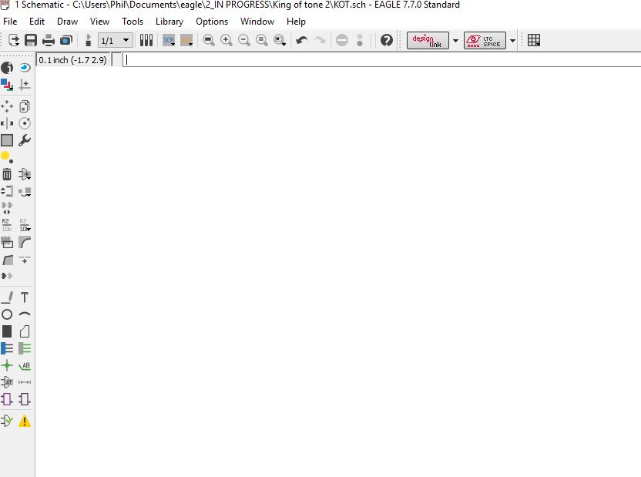
- This will open the add component sub-menu. You’ll use this a lot so get use to the contents.

- If there is anything already loaded here select the Un-use button until you have a clear diologue box
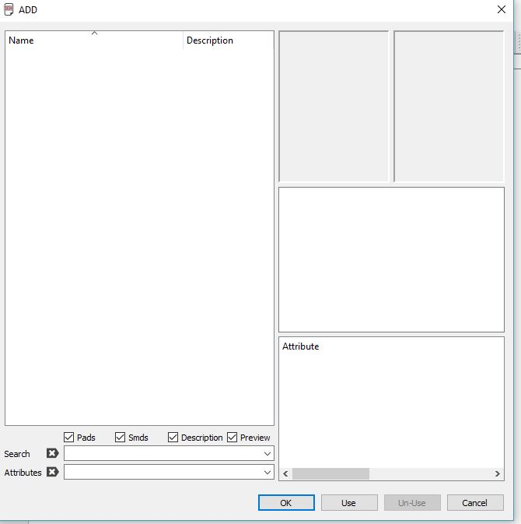

- Once it is clear select add, navigate to the MB2016 lbr. Select all the libraries in the folder (Ctrl + A) and select open. This should populate the add menu with all of the Madbean libraries. (You can do this with any libraries that you want, although I’ve never used anything else tbh).

- You should end up with a add window that looks like this
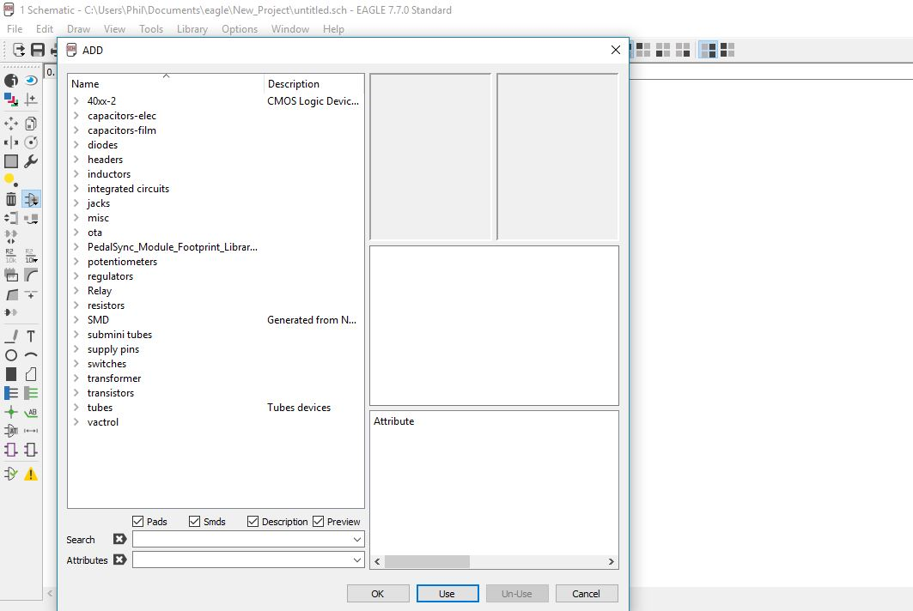

You should now be ready to rock and roll.

- Drawing your schematic
Before you start drawing here’s a few tips

The escape key and undo (ctrl+ z) are your best friends (if you use windows)
Get used to using the escape key, if you are drawing a net and you need to stop for any reason use esc, if you move a component and you change your mind > esc. Undo (ctrl + z) is also really useful, but it seems to be the only windows command that works. Cut and paste do not work which is a real pain in the ass.

The Grid
Enter the grid menu using this icon (in either schematic or board windows).
Toggle the grid view on or off from here, this can be displayed as dots or lines.
The default grid is 0.05” and you should attempt to keep it that way.
The only time I change this is when I initially define my board dimensions (usually 50x50mm), or if I need to do fine positioning of text on the silkscreen (covered in the board guide).
The reason is the components are designed in eagle to a fixed grid size, if you change the grid size you might have trouble aligned components to the NET or other components.
Another reason is component spacing on the board, most components have a standard leg / pin spacing which is in increments of 0.1”. If you start using millimetres for the grid is gets messy.
If you find that a component won’t align to a schematic or board you can use the ctrl + Left mouse click to make the component snap to the current grid.

Drawing your NET
You can draw your circuit anyway you choose (and any size you want, give yourself lots of space for placing components), I prefer to lay down the NET first and drop the components onto it later. This requires a little extra work because you have to delete the unwanted net underneath the components but it does ensure that all of the components are attached to the NET.
(Note. For some stupid reason (I suspect it has to do with the grid that the components are created on) some components will not attach themselves to the end of the NET drawing tool meaning that they wont be connected to the circuit) You can get around this by drawing the net underneath and placing the component on top. You will end up with a junction either side of the component which can be deleted 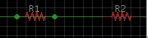
(R1 with junctions either side, R2 with junctions deleted)
- Select the NET tool 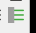 (the green one!)
- Draw the wires of the circuit. You can toggle between different wire bend styles 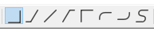 by using the right mouse button whilst the NET tool is active.
- Overlapping NET is only connected if there is a junction (green spot) 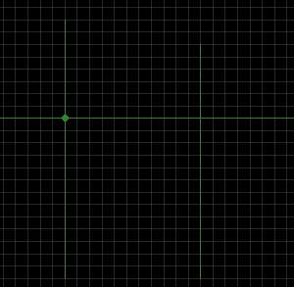
The left hand NET has a junction and is therefore connected, the right hand overlap is not connected)

You can manually add a junction with the junction tool

Components on the schematic
There’s no hard and fast way to do this but the golden rule is Always place components on the schematic as you want them on the board i.e make sure you have the right component package.
What i mean by this is that there are hundreds of resistors, caps, trannies etc and they generally all look the same on the schematic.
The difference lies in the properties that they have on the board. Not only does this include pad spacing but also pad size and the artwork that is applied to the screen print layers (tPlace or bPlace).
As a rule i use a 4mm spacing for resistors (R_.3B) and a 3mm spacing for non polar caps (CER/FILM2)(i use multilayer monolithic). Electrolytic spacing depends on the size of the cap.
With Transistors, IC’s, Pots and switches you need to be aware of the component package and the pad spacing.
The useful thing is that when you go to your library to add a component the spacing and package are displayed in the top right corner
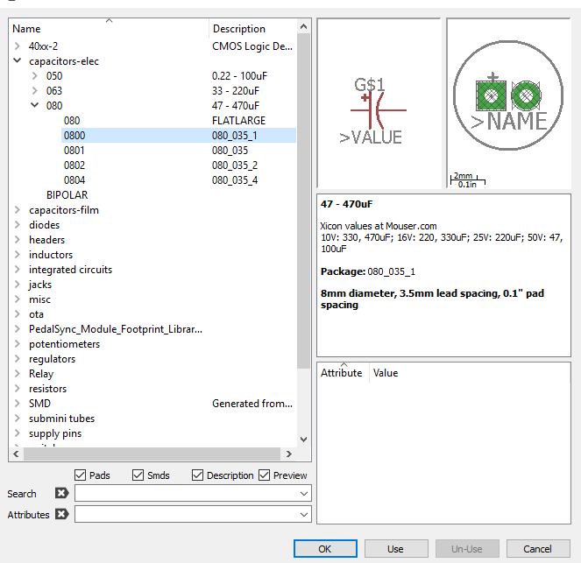

If you cant find the component you need (i.e a particular metal can PNP transistor or an IC) look for something with the same package , you can rename the component on the schematic and the pad arrangement on the board will be the same. JUST BE VERY CAREFUL WITH THE PIN OUT!!!!!

Examples
PNP Ge transistor
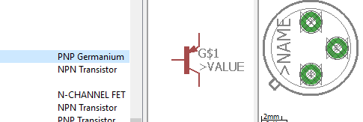
NPN transistor (TO92 package)

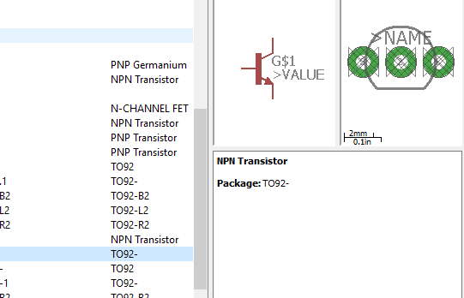

Placing your components
Once you have drawn your NET select your components using the Add icon.
Remember that components you select here need to have the package that you desire on the PCB and have the leg / pin spacing which is right for the components that you are going to use.
Use the smallest size you can get away with because it makes arranging the board and routing easier (especially if you are limited to size with pcb manufacturers)
I tend to use multilayer monolithic caps which have a standard leg spacing of 0.3” and resistors with a 0.4” leg spacing.
Be careful with electrolytic caps and box caps to make sure that the leg spacing is right, you can check the size in board view by using the grid tool. You can also check with a piece of vero which has 0.1” spacing.
Make sure that the hole in the pad is big enough to take the component. The major difference between the Gaussmanov and Madbean libraries is the pad size. The Gaussmanov pads are very small and you won’t be able to mount some components like 1N4001 diodes because of the leg thickness.
- Spacing
As a rule I use:
resistors 0.4” spacing, (no smaller than 0.3” unless you want them standing)
multilayer monolithic caps 0.3” spacing
electrolytic caps Depends on the cap value (smaller values 0.2”, larger values 0.3”+)
Diodes 0.4” spacing (smaller for diodes like 1n4148)
- Orientation
When placing your components use the right mouse button to rotate the component. You can use the icons at the top of the menu to mirror and rotate components to get them round the right way
Take extra special care with IC’s, switches, Pots and trannies to make sure that the pins / legs / lugs etc are orientated correctly
- Switches and IC’s with multiple sub-parts
Some IC’s and switches have multiple parts which can be placed in different positions on your layout i.e the different “poles” of a 3pdt switch. When you select the component the different parts are available to place individually and will be marked Part X A / B / C etc. When the component is then placed on the PCB board the pads will be arranged depending on the component package you have selected.
- Missing connections
Some IC’s have pins 4 & 8 missing, these can be revealed by selecting the component and using the XXXX command (right-click)

Pads
Input / output / +9v require pads. You can use pads for almost anything, I’d recommend the square type as they take solder better.

GND Pads
This is really important!!!! GND pads need to be attached to a GND supply component or the pad itself will not run to ground on the PCB.
Example

Switches
Check package (board mount, big pads, small pads etc). Separate parts of the switch can be placed around the schematic as described above but will appear together according to the package on the PCB.

Pots / trimmers
Check package (board mount, big pads, small pads etc). Check lug orientation

Transistors
Check package and transistor pin out orientation. I’ve been caught out here using a transistor with a different pin out, Be careful!

IC’s
Check package and pin out orientation. Hidden pins can be revealed using the XXX command (see above)

Names and values
Components will be assigned a sequential number as they are added to the schematic. This is fine, but you may want to number them as you see fit. To rename a component use the icon. Eagle won’t let you have duplicate numbers which is very sensible but can be irritating.
You can add component values as well by using the icon, this isn’t essential but you can get Eagle to generate a Bill of Materials which is very useful, so if you want one adding the values is advisable.

Substituting parts / Alternative packages
Most components can be substituted relatively easily if you choose the wrong package. Right click on the component and use “Package” you should then be able to swap to the required alternative package.
If you need an alternative component (an electrolytic cap instead of a non-polar) Right click the component and use the “Substitute” command. In most cases this will worl, if it doesn’t you’ll have to delete it and add a new component from the library (remember to rename it and give it a value as these will be deleted along with the component.
- Electrical rule check
The electrical rules check will make sure everything is connected as it should be; that components are named and have values etc, etc

- Generating a board
Once you are (relatively happy) you can generate your board by using the ICON.

Forward and back notation
It is a very good idea to keep the schematic and board open at the same time when you are working on it, it will allow you to make adjustments to the schematic, which will automatically update the board. For example, you have used the wrong package for a component and you want to update it.
If you close the either the schematic or board windows you will lose this function.
Beware, if you change the schematic without the board being open and they do not match you will lose the forward back notation and you can get yourself in some trouble.
The only time this may be desirable is if you want to panelise your pcb’s to make the most of the manufacturers default board size.

Board guide follows >>> (eventually)

